ELECTIVE PAPER – 1
A. ANALYTICAL CHEMISTRY – 1
• To impart knowledge about Data Analysis, Purification of organic compounds, Different Spectroscopic Techniques and their Application.

UNIT – I
1.1. Data analysis – Types of errors – Correction of determinate errors - Idea of Significant Figures and their Importance with examples – Precision and Accuracy – Methods of expressing Accuracy.
1.2. Error analysis – Minimising errors – Methods of expressing Precision – Average deviation – Standard Deviation and Confidence Limit.
1.3. Purification of Solid Organic Compounds – Solvent extraction – Recrystalisation – Use of immiscible solvents – Soxhlet extraction – Crystallisation – Use of miscible solvents -Fractional Crystallisation and Sublimation.
UNIT – II
2.1 Purification of liquids – Experimental Techniques of Distillation – Fractional Distillation – Vacuum Distillation – Steam Distillation – Tests of Purity.
2.2 Gravimetric Analysis – Characteristics of Precipitating Agents – Condition of Precipitation – Types of Precipitants – Purity of Precipitate – Co-precipitation and Post precipitation – Precipitation from Homogeneous Solution – Digestion and Washing of precipitate – Ignition of precipitate – Uses of Sequestering Agents.
2.3 Definition of spectrum – Electromagnetic radiation – Quantization of different forms of energies in molecules (Translational, Rotational, Vibrational and Electronic) – Born- Oppenheimer approximation – Condition of energy of absorption of various types of spectra.
.UNIT – III

3.1 Microwave Spectroscopy – Theory of Microwave Spectroscopy – Selection Rule – Calculation of Moment of Inertia and Bond Lengths of Diatomic molecules – Effect of Isotopic Substitution.
3.2 UV – Visible Spectroscopy – Absorption laws - Calculations involving Beer- Lambert’s law – Instrumentation – Photocalorimeter and Spectrophotometer – Block diagrams with description of components – Theory of Electronic Spectroscopy.
3.3 Types of Electronic Transitions – Chromophore and Auxochromes – Absorption bands and Intensity – Factors influencing Position and Intensity of Absorption Bands - Frank- Condon Principle – Applications.
UNIT – IV
4.1 IR Spectroscopy – Principle – Theory of IR spectra – Vibrational Degrees of Freedom - Modes of Vibration of Diatomic Molecules –Triatomic linear (CO2) and Non-linear Molecules (H2O) - Stretching and Bending vibrations – Symmetric and Asymmetric Stretching vibrations - Selection rules.
4.2 Expression for Vibrational Frequency (Derivation not needed) – Calculation of Force constant – Factors influencing Vibrational Frequencies - IR Spectrophotometer - Instrumentation – Source, Monochromator, Cell, Detectors, Recorders and Sampling Techniques.
4.3 Applications of IR Spectroscopy – Identification of Functional Groups - Interpretation of the spectra of Alcohols, Aldehydes, Ketones and Esters (Aliphatic and Aromatic) - Hydrogen bonding.
UNIT – V
5.1 Raman Spectroscopy - Rayleigh and Raman scattering – Selection rule – Raman shift - Stokes and Anti-stokes lines - Differences between Raman and IR Spectroscopy.
5.2 Raman Spectrophotometer - Instrumentation – Block diagram – Components and their Functions – Advantages of using Laser in Raman Spectroscopy – Applications – Structural elucidation in the study of Inorganic and Organic Compounds.
5.3 Rotational-Raman spectra of Non - Centrosymmetric molecules - Mutual exclusion principle (CO2 and N2O) - Applications – Structural diagnosis.

Reference Books
• Elements of Analytical Chemistry – R. Gopalan, P. S. Subramanian, K. Rengarajan – S. Chand and sons (1997).

Fundamentals of Analytical Chemistry – D. A. Skoog and D. M. West, Holt Reinhard and Winstor Publications – IV Edition (1982).
Principles of Instrumental Methods of Analysis – D. A. Skoog and Saunders, College Publications, III Edition (1985).
Analytical Chemistry – S. M. Khopkar – New age Insternational Publishers.
Instrumental Methods of Chemical Analysis – Chatwal - Anand, Himalaya Publishing House (2000).
Analytical Chemistry – R. Gopalan, Sultan Chand.

•

DATA ANALYSIS
DEFINITION OF ERROR
The difference between the measured value of a property and it's accurate value is called the error Eg. We measure the weight of an object or the volume of a solution. Accurate results will be got when persons with great skill do the measurements with best instruments. This is nearly Impossible. Usually the measured value of the property will never be the accurate value of the property. The difference between these two is called the error.
CLASSIFICATION OF ERRORS
The Errors are classified into two types.
- determinate errors
- indeterminate errors or random errors
DETERMINATE ERRORS (also called systematic errors)
These are errors which have a definite value and an assigned cause. The analyst can measure and account for these errors. These can be avoided. They are unidirectional. The errors will be either more or less than the accurate value.
SOURCES OF THESE ERRORS
- Defective instruments
- careless operation
- procedural defects
CLASSIFICATION OF DETERMINATE ERRORS
- Instrument errors
- method errors
- personal errors
INSTRUMENT ERRORS
When We use balances, weights, pipits, burettes, etc., We must make sure that they are not defective. For example a weight marked 10g may not be 10g after all. So to avoid these errors one must use best instruments. This error may be identified by changing the instrument, the error will also change.
METHOD ERRORS
These are introduced by defective experimental procedures.
E.g. (i) coprecipitation or post precipitation in gravimetric analysis.
(ii) Usage of improper indicators in volumetric analysis. So to avoid these, one must be thorough with the theoretical part of the experiment
PERSONAL ERRORS(ALSO KNOWN AS OPERATIVE ERRORS)
These are introduced by Personal defects are carelessness. The sources of this error are human defects in eyes, mind etc., In colorimetric experiments errors will be introduced by a person who is colorblind. A person with defective eyes will invariably note readings erraneously. Carelessness fattigue and improper instructions from the teacher also introduce these errors. Several mistakes may creap. In example wrong calculations wrong placement of decimals come on noting wrong signs, cooking results ETC dot this can be avoided if one works rap pulseless sleep in the laboratory.
Determinate errors may also be classified as being either constant or proportional.
CONSTANT ERRORS
A Constant error will become more Serious As the size of the quantity measured decreases. So to minimize the effect of constant error we have to uses large sample.
PROPORTIONAL ERRORS
These are errors whose magnitude increases or decreases in proportion to the size of the sample taken for analysis. Invariably impurities in the sample, if not removed, will cause a proportional error.
CORRECTION OF DETERMINATE ERRORS
Determinate instrumental errors are corrected by calibrating the instruments concerned. The equipments are to be calibrated periodically. This is because instrumental errors arise due to wear corrosion or mistreatment. Determinate personal errors can be minimized by care and self discipline. Instrument readings, note book entries and calculations should be checked systematically. Determinate method errors are particularly difficult to detect. They may be corrected by one or more of the following procedures;
- Analysis of standard samples
- Independent analysis
- Blank determination
- By taking large sample size
RANDOM ERRORS OR INDETERMINATE ERRORS
They are errors arising from uncertainities, in measurement that are unknown and not controlled by the person doing an experiment.
SOURCES
- Instrument uncertainities
- Method uncertainities
- personal uncertainities
IDENTIFICATION
Identification of indeterminate errors is difficult. Scatter of data about the mean is the effect of an indeterminate error.
MINIMISING ERROR
- Blanks experiments are to be conducted along with the regular ones.
- Almost care is taken to avoid personal errors.
- Arithmetic mistakes, etc., Should not be committed.
- While taking readings one must be very careful to note the correct reading.
- Without getting proper and complete instructions. The experiment should not be done.
- When one becomes tired, the experiment must be stopped in a convenient place and continued after taking sufficient rest.
PRECISION
DEFINITION
It is the degree of agreement between two or more measured value of property measured under identical condition.
EXPLANATION WITH EXAMPLE
Let the weight of a beaker be 23.0326g when weighed in a particular set of conditions. If the same beaker is weighed under identical conditions and if the weight got is the same 20.0326g then we say that there is precision in the weighing. Thus if a value is reproducible then it is called precise value.
ACCURACY
DEFINITION
It is the degree agreement between measured value and the expected or true value of property.
EXPLANATION WITH EXAMPLE
As per analytical data available, the solubility product of Agcl is 1.8× 10 to the power minus 10.If an Analyst gets this same value while determining the same in an experiment, then, it is said accuracy of the result is excellent. If it differs, we calculate the deviation. This deviation gives a measure of the accuracy of experiment.
METHODS OF EXPRESSING ACCURACY
Accuracy is expressed in t terms of of absolute or relative error. The lower these values are the more will be the accuracy.
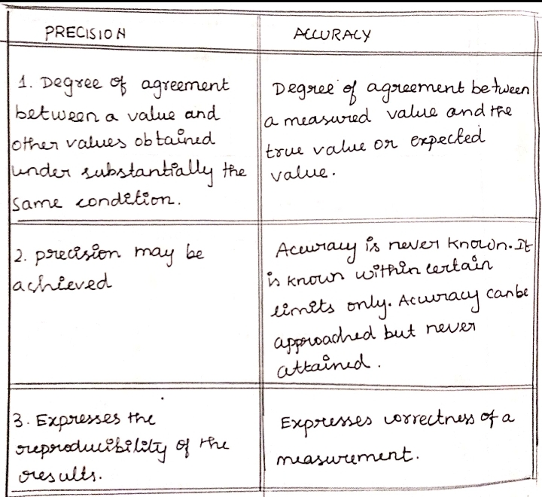
ABSOLUTE ERROR(E): DEFINITION
It is defined as the difference between the expected value and the observed value
mathematical expression
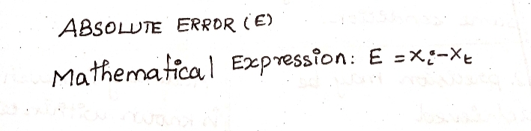

RELATIVE ERRORS(RE): DEFINITION
It is the error percentage of the accepted value
Mathematical expression.
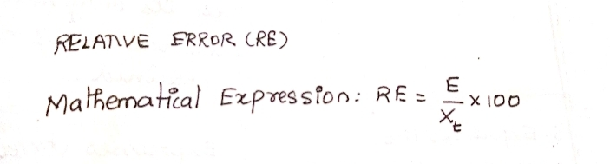
METHODS OF EXPRESSING PRECISION
Precision is expressed by two methods
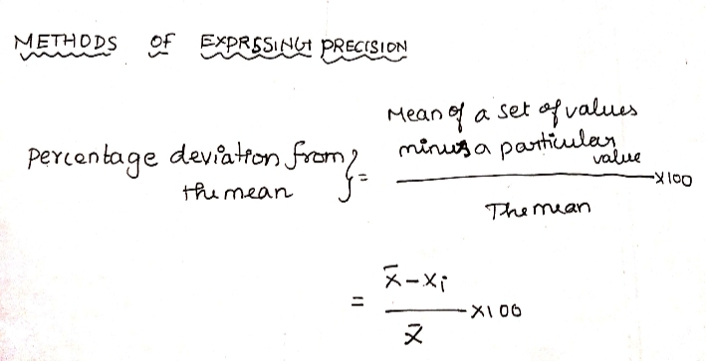
(i)Absolute method
(ii)relative method
ABSOLUTE METHOD
In this method the precision is expressed in terms of average mean deviation. The smaller the value of average mean deviation the greater will be the precision.

RELATIVE METHOD
In this method the precision is expressed in terms of percentage deviation from the mean of a set of values.

To understand the above two methods let us learn some terms used in statistics.
MEAN
Mean is the quotient obtained when the sum of a set of replicate measurements by the number of individual results in the set.
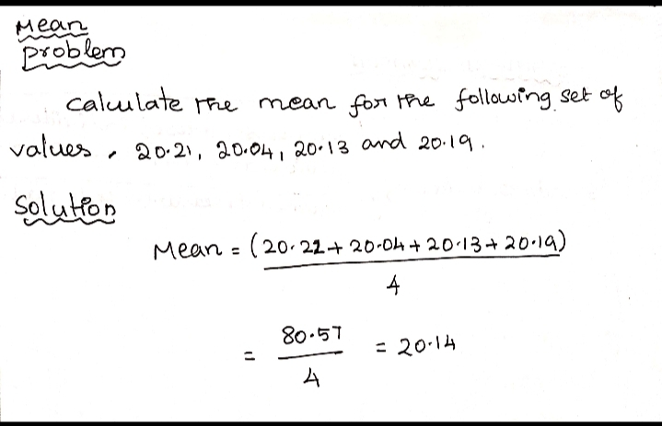
MEDIAN
It is the value about which all other values are equally distributed. Half the values will be greater and the other half smaller than the median.
The median is obtained by arranging the set of values in increasing or decreasing order. If there are odd number of values then the middle value gives the median. If there are even number of values than the average of the middle pair gives the median.
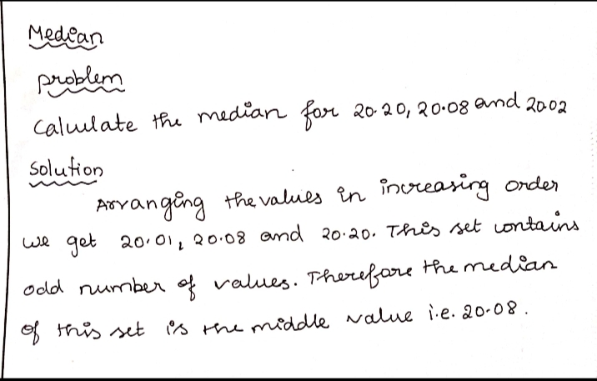
MEAN DEVIATION (Also known as average deviation)
DEFINITION
The average deviation of a value in a set of values is the average of the deviation of all the individual values from their average.

USES
If the mean deviation of a set of measurements is small it means that the average of that set is nearly precise.
STANDARD DEVIATION
DEFINITION
It is the square root of the quotient obtained by dividing the sum of the squares of the individual deviations from their mean by the number of measurements made.
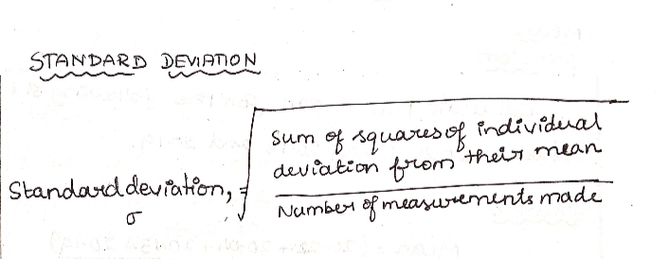

CONFIDENCE LIMIT
They are the limits, which may be set, about the experimentally measured mean(x) with in which we may expect to find the true mean(u) with a given degree of probability.
SOLVENT EXTRACTION
DEFINITION
It is separation technique you adopted to separate a solid or liquid present in a mixture by extracting it with a solvent.
PRINCIPLE
The substance to be extracted should be soluble in a particular solvent while all the other constituents in the mixture should be insoluble. After extraction the solvent should be easily separable.
SUPERIORITY OF SOLVENT EXTRACTION OVER PRECIPITATION METHODS
- 100% separation is achievable in solvent extraction method. In precipitation methods there is a possibility of some substance remaining in the mixture ,i.e., efficiency is more.
- The procedure part is simple
- In solvent extraction Method a small amount of solvent is enough as it is recovered and recycled
USES
Solvent extraction is used to separate
- Dissolved substance from their solutions.
- One constituent from a solid mixture
- Unwanted impurities from substances.

RECRYSTALLISATION
Recrystallization is a technique used to purify chemicals. By dissolving both impurities and a compound in an appropriate solvent, either the desired compound or impurities can be removed from the solution, leaving the other behind. It is named for the crystals often formed when the compound precipitates out. Alternatively, recrystallization can refer to the natural growth of larger ice crystals at the expense of smaller ones.
SOXHELT EXTRACTION
DEFINITION
It is the extraction a solid with an organic solvent, in which the impurities are insoluble, using the soxhelt extractor.
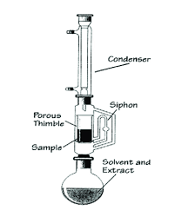
PRINCIPLE
The substance to be e extracted should be soluble in a particular solvent while all the other constituents in the mixture should be insoluble. After extraction the solvent should be easily separable.
PROCEDURE
Soxhelt extraction consists of a glass cylinder C with side tube T and a syphon S. A water condenser is attached at the top of C(figure)
The sample from which the solid to be extracted is powdered.
It is powdered in thimble made of a thick filter paper. Thimble is placed at the the bottom of the water condenser. The extracting solvent is taken in the boiling flask. The solvent is boiled. Its vapour rise through T and enters the water condenser. There, the vapour condense. The condensed solvent falls on the sample in the thimble. The substance to be extracted dissolves while the impurities don't. The solution is filtered by the thimble and collects at the cylinder C. When C becomes full, the solution reaches the flask through T. The extracted solid remains in the flask. Thus the solvent extracts the solid continuously from the sample and bring it to the flask. Finally the solution from the flask is distilled. The solvent distills off, leaving behind the organic substance.
CRYSTALLISATION
This is one method of purification of solid.
This process is commonly employed for the purification of solids compounds. The impure solid is dissolved in the minimum volume of suitable solvent. The soluble substances pass into solution while the insoluble ones are left behind. The hot solution is then filtered and allowed to cool undisturbed till crystallisation is complete. The crystals are then separated from the mother liquor by filteration and dried. The efficiency of the process of crystallisation depends on choice of the solvent preparation of solution filtration of the solution crystallization and separation and drying of crystals.

FRACTIONAL CRYSTALLIZATION
Fractional crystallisation is a method of refining substances based on differences in their solubility. It fractionates via differences in crystallization (forming of crystals). If a mixture of two or more substances in solution are allowed to crystallize, for example by allowing the temperature of the solution to decrease or increase, the precipitate will contain more of the least soluble substance. The proportion of components in the precipitate will depend on their solubility products. If the solubility products are very similar, a cascade process will be needed to effectuate a complete separation. Fractional crystallization can be used to separate solid-solid mixtures. An example of this is separating KNO3 and KClO3.
SUBLIMATION
DEFINITION
Sublimation is a process in which a solid when when heated passes directly into the vapour state without melting and the vapour when cooled, become solid directly without condensing into a liquid.
PRINCIPLE
Certain substances when heated, pass directly from solid to vapour state without memelting. The vapours when cooled ,give back the solid substance. This process is known as sublimation. The process of subimation is used in the purification of volatile Solids like Naphthalene, camphor etc., from non-valatile solids.
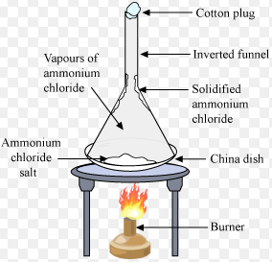

TECHNIQUE
1] SUBLIMATION UNDER ORDINARY PRESSURE
The solid to be purified by sublimation is placed in a china dish placed on a sand bath. The china dish is covered with a perforated filter paper. A funnel is inverted over the china dish. The china dish is gently heated. The sublimable solid evaporates, passes through the pores of the filter paper and is deposited as a pure solid on the walls of the funnel. The filter paper prevents the sublimed solid from falling back into the china dish and prevents the funnel from getting the heat and thus keeps it cool.
2] SUBLIMATION UNDER REDUCED PRESSURE
Substance purified by direct sublimation. For such substances, sublimation under reduced pressure is effected. The apparatus for this is shown in figure. In this apparatus there is a small space between a large heating suface and a large cooling surface. On heating the solid sublimes and condenses as a solid at the bottom of the surface cooled by water.
USE
This technique is used for the purification of sublimation solids like camphor, naphthalene, benzoic acid etc.,

